Youth Sport Trust School Storytelling Toolkit

# Introduction

As part of your involvement in a YST programme, we have asked you to share your experiences with us so we can understand how it is working in your school or area.

For you and your school, sharing your experience and stories can help to:

* Demonstrate the impact you have had and celebrate the difference you have made
* Share progress and impact with key stakeholders like Governors, Parents and Senior Leadership Team
* Share information about Youth Sport Trust programmes and share ideas between schools

## Please follow these four key steps when generating your story:

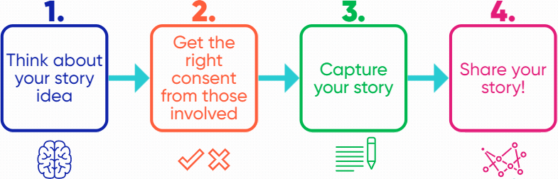

## Questions?

If you have any questions about this storytelling toolkit, please get in touch with your Programme Manager at the Youth Sport Trust, or the Research & Insight Team at research@youthsporttrust.org.

Throughout this document, use the ‘CLICK HERE’ links to download the resources and templates.

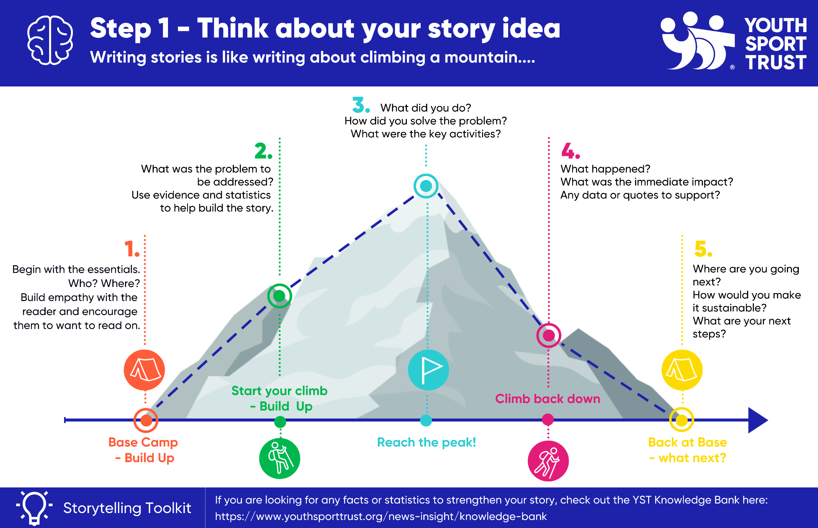





**Step 2**

**Get the right consent from those involved in your story**

**Remember consent!** When you are initiating conversations with an adult or young person about producing a written story of what they are doing it is important that you tell them why you are doing this and what you are hoping to use it for.

**For all young people (under 18) you will need to get parent / guardian signed consent before you start writing the story.**

**It is important that the consent form is signed by the parent / guardian of a young person under 18 and not by the teacher on behalf of a parent / guardian.** (We will not be able to use the story of a young person if the consent form is signed by a teacher on a parent / guardian’s behalf.

1. Where an individual is named or shown in video / photo format (young person or adult) parent / guardian consent is needed.

|  |  |
| --- | --- |
| Young person – parent consent form | [**CLICK HERE**](https://www.youthsporttrust.org/media/2npnjhxj/young-person-parent-consent-form.docx) |
| Individual – consent form (18+ only) | [**CLICK HERE**](https://www.youthsporttrust.org/media/jy0n15ju/individual-journey-consent-form.docx) |

1. If you are only naming your school, please sign the school consent form below and return it to YST with your story.

|  |  |
| --- | --- |
| School consent form | [**CLICK HERE**](https://www.youthsporttrust.org/media/gligg23o/school-journey-consent-form.docx) |

At YST we need evidence of consent otherwise we cannot share your story externally through our channels. Please make sure when you send us your story you also return the right signed consent forms.





**Step 3**

**Capture your story**

**Consider alternative ways to tell your story – it doesn’t always have to be written!**

* **Video** (see an example here: [**https://youtu.be/deCZEeYpaxk**](https://youtu.be/deCZEeYpaxk))
* **Written** (see an example here: [**https://www.youthsporttrust.org/news-insight/case-studies**](https://www.youthsporttrust.org/news-insight/case-studies)**)**
* **Comic Strip**
* **Voice notes**

You can also use some of the templates and activities in the appendix to help you to capture the information. You can then submit the completed templates as they are, or you can use the templates as a way to gather the details for your story and then tell your story in another way, such as those examples above.

**Use the checklist below to make sure you have included all of the key information**

|  |  |
| --- | --- |
| ☑ | …information about your school. This would include school name, location, demographics. |
| ☑ | …information about the YST programme, what was the name, when did it run? |
| ☑ | … why you / your school decided to get involved in the YST programme? Why was it needed in your school? |
| ☑ | …detail about who was involved? Who were the target group of young people? What is the age range? Don’t forget to include your information too if you are the teacher – name, role, subject you teach etc |
| ☑ | …what did you do as part of the programme? What activities you delivered? When and where. |
| ☑ | …detail on the impact of the programme, for example this can be on yourself, young people or the whole school or community. |
| ☑ | …the biggest success! |
| ☑ | …information about what next for your school and this programme. |

If you are planning to create a video, please see our top tips for video filming, [**CLICK HERE**](https://www.youthsporttrust.org/media/mlpoaz0o/top-tips-for-video-filming.docx)



Check whether you have included the following key information -

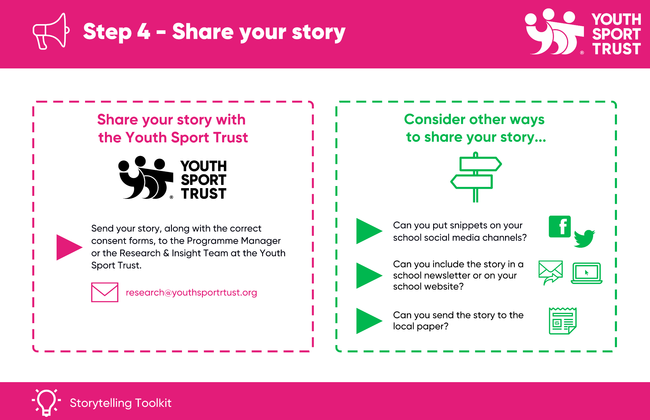

**Are you a Changemaker?** If think your story is worthy of a Young Changemaker Award or similar, we would love to nominate you. We’ll be in contact if we want to use your story as a submission!

**Appendix: Further reading and support**

Here we share some previous examples of stories and templates that you could use to capture the content for your story. We also share more information about storytelling and some links to any further reading / videos to watch if you are interested.

## Previous examples

Here are some previous examples where we have written up stories from schools/young people completing the templates, or where schools/young people have submitted their own written story.

School stories told by a school/teacher:

**Westfield Academy**

****[**CLICK HERE**](https://www.youthsporttrust.org/media/lvnlfiww/westfield-school-story.pdf)

**The Bemrose School**

****[**CLICK HERE**](https://www.youthsporttrust.org/media/cmrgl5pe/bemrose-school-story.pdf)

School stories told a young person / young people stories told by a young person:

**Beacon Academy**

****[**CLICK HERE**](https://www.youthsporttrust.org/media/gukjfkp5/beacon-glams-story.pdf)

**Whitchurch High School**

****[**CLICK HERE**](https://www.youthsporttrust.org/media/a5zdnybr/whitchurch-influencer-story.pdf)

**Little Acorns**

****[**CLICK HERE**](https://www.youthsporttrust.org/media/gm5larmr/little-acorns-young-person-story.pdf)

## Decide how to tell your story

Not sure where to start? We have provided a number of templates to help get started with recording your story in the next section.

The below chart might also help you decide what story you want to tell and how best to start recording it using the templates provided in the next section.

You can then submit the templates as they are, or you can use the templates as a way to gather the details for your story and then tell your story in another way, such as a written piece, a video, or a presentation. If you are planning to create a video, please see our top tips for video filming.

## Templates

The following templates and activities can be used to help you capture your story. Remember, you can then submit the templates as they are, or you can use the templates as a way to gather the details for your story and then tell your story in another way, such as a written piece, a video, or a presentation. If you are planning to create a video, please see our top tips for video filming.

|  |  |
| --- | --- |
| Document | Link |
| An Introduction to storytelling  *More information and links with how to write a good story.* | **Cursor with solid fill**[**CLICK HERE**](https://www.youthsporttrust.org/media/ah2iqy3n/an-introduction-to-storytelling.docx) |
| Who, Why, What?  *This template can be used to gather the key details of the story. You could then use this to create a written story, presentation, video or just keep it in this template.* | **Cursor with solid fill**[**CLICK HERE**](https://www.youthsporttrust.org/media/ajpdrhqt/who-why-what.docx) |
| Review and Reflect  *This is a different way to think about and reflect on what you have done. Review your journey and think about telling your story from the beginning to end.* | **Cursor with solid fill**[**CLICK HERE**](https://www.youthsporttrust.org/media/lfplhg54/review-and-reflect.docx) |
| Weekly Reflection  *This is a different way to think about and reflect on what you have done each week or session, so that you can record your story from early on in the programme.* | **Cursor with solid fill**[**CLICK HERE**](https://www.youthsporttrust.org/media/zaqom3j3/weekly-reflection.docx) |
| Bringing it To Life: A Video or Presentation  *This template can help you turn your school’s story into a PowerPoint presentation or a video. This gives you chance to make your story visual and engaging and means you could present it back to others.* | **Cursor with solid fill**[**CLICK HERE**](https://www.youthsporttrust.org/media/3akbr2qu/bringing-it-to-life-in-a-presentation-or-video.docx) |
| Tweet Challenge  *This can be used by asking an adult or young person to complete. It might be useful if you want a short snappy quote from another teacher or member of SLT to enhance your story*. | **Cursor with solid fill**[**CLICK HERE**](https://www.youthsporttrust.org/media/rupjcyjn/tweet-challenge.docx) |
| Dear Diary  *This activity could also be used by yourself or a young person to complete as part of their journey through a programme.* | **Cursor with solid fill**[**CLICK HERE**](https://www.youthsporttrust.org/media/mr4mj3m4/dear-diary.docx) |
| Post Card  *This can be used to capture feedback from a group of young people and can feed into the story development. You can use any numbers gathered through this activity to strengthen the story you are trying to tell.* | **Cursor with solid fill**[**CLICK HERE**](https://www.youthsporttrust.org/media/fy3hpbl5/post-card.docx) |
| Fact File  *This could be completed together with a young person or be provided for them to complete on their own. If you feel that this captures the right information for your audience, then this could be a final output on its own.* | **Cursor with solid fill**[**CLICK HERE**](https://www.youthsporttrust.org/media/jvnbwewx/fact-file.docx) |
| Story Template  *This is a PowerPoint template with questions on your journey for you to answer if you wish to create a more visually engaging story to share with others - this could be a final output on its own.* | [**CLICK HERE**](https://www.youthsporttrust.org/media/dxjbs3h0/draft-school-s-story.pptx)  **Cursor with solid fill** |

Double click to open each document in the ‘link’ column.

Youth Sport Trust

SportPark

Loughborough University

3 Oakwood Drive

Loughborough

Leicestershire

LE11 3QF

01509 226600

research@youthsporttrust.org

[www.youthsporttrust.org](http://www.youthsporttrust.org)

](https://twitter.com/youthsporttrust)

Registered Charity Number 1086915

Registered Company Number 4180163