Section 1: School context
School Name |  | The Grange Community Primary School
Location |  | Banbury
School vision and values |  | SCHOOL VISION  Our children will reach their maximum potential through high standards in teaching, learning and leadership. We will provide a caring, inclusive learning environment where everyone is valued and respected and prepare our children to become valuable members of the wider global community.  The Grange Way  I listen to learn  I keep healthy and have a positive attitude  I smile and say hello  I care for everyone and everything  I work hard to challenge myself
Staff member name and title |  | Lucie Smith-Childs  PE Lead
Submission date of Quality Mark |  | March 2022
Section 2: Intent
Rationale |  | We complete Quality Mark as it allows us to unpick all the parts of our PESSPA offer to make sure that we are the best we can be.
Vision |  | Our vision for PE is clear and simple. We have additional vision statements for school sport and physical activity.  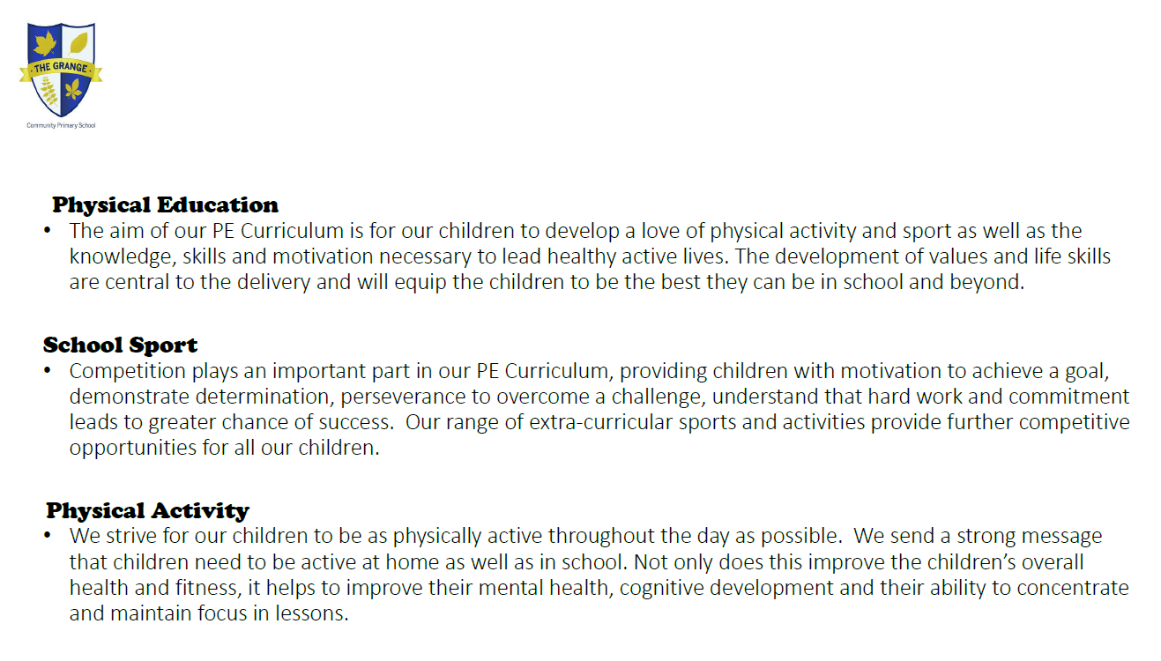  We have a child facing version too which is displayed in the main hall at school and on the school website  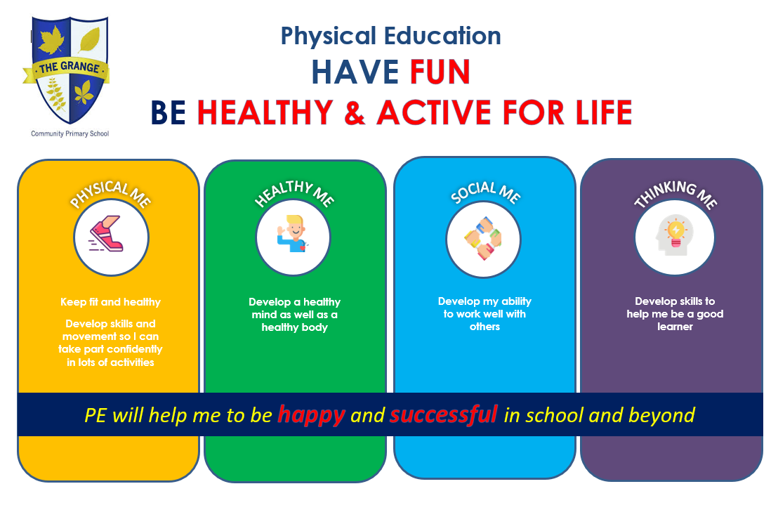  Personal development is central to everything we do at The Grange and PE is highly valued for developing the whole child. When you ask the children about the skills that they’ve been developing in PE, they will talk about the emotional, social and thinking skills as well as the physical. A combination of My Personal Best training and resources, Will Swaithes Curriculum Design Course, Complete PE and pupil voice has helped me develop and embed our curriculum. The life skills/values link really well to The Grange Way and are referred to in all aspects of school life. We have an interactive PE board in the hall with the vision and life skills/values on as well as a big display board in the entrance hall with pictures of children demonstrating the different skills.
Section 3: Implementation
Curriculum | We used some of our SPG to buy into Complete PE. I really like the emphasis on the development of the whole child and its breath of activities as well as the flexibility it offers. I have designed a 2 year rolling programme to align with the rest of the school. All the children have 2 hours of PE each week, one games based lesson and the other dance, gymnastics, OAA, fitness or athletics. Units are linked to the schools main themes and projects where possible, especially in dance.
Teaching and learning | Teachers complete a confidence survey at the beginning of the academic year which informs me of needs. As a trained PE teacher and NOSSP mentor, I’m well placed to carry out observations and offer 1 to 1 support to my colleagues. Everyone’s had an observation this year with detailed feedback and targets set. I’ll do some learning walks as well and re-visit targets during T5. We access regular, high quality CPD through NOSSP and staff attend based on their identified needs.  High quality PE at The Grange –  Everyone engaged and enjoying the lesson  Good structure to the lesson  Everyone clear about the purpose of the lesson  Not just a physical focus but a social/emotional/thinking focus too  Quality feedback which drives progress  Differentiated activities to allow everyone to be challenged  Children reflecting and evaluating
Assessment | Summative assessment is carried out by teachers at the end of each termly unit using the Complete PE assessment tool which incorporates personal development of the whole child. Children are levelled as either Emerging, Developing, Secure or Exceeding, in accordance with Age Related Expectations as per the Assessment Procedures for the curriculum areas covered. Collected data is reviewed to check progress to inform future planning and to identify children below age related expectations in 1 or more of the activity areas who will be targeted for additional support (physical activity interventions/extra-curricular involvement). Children’s progress is reported to parents and carers.  Alongside this, our KS2 children complete self-assessments at the end of each unit on the physical, social, emotional and thinking skills within it, identifying and celebrating their achievements and setting themselves targets for improvement (example attached). Targets are re-visited when relevant. KS2 children also complete more in-depth life skill/value self-assessments at the end of each term which allow children to reflect and evaluate (example attached). These are analysed and used to target children for additional support (physical activity interventions/extra-curricular involvement). The assessed life skill/values align with the taught units and are highlighted on the Curriculum Maps of Key Learning.
Anything additional you would like to add | Complete PE  My Personal Best
Section 4: Impact
Benefits  Include quantitative data, examples and quotes |  | 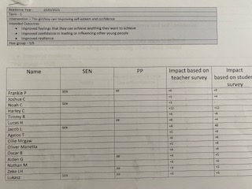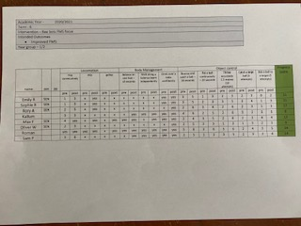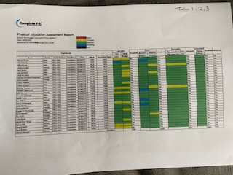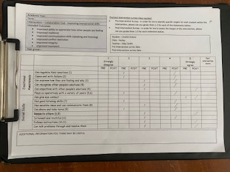  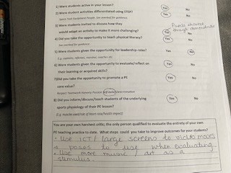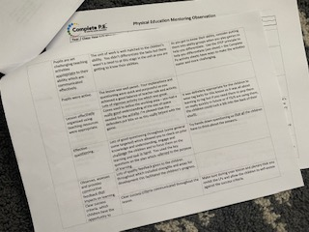  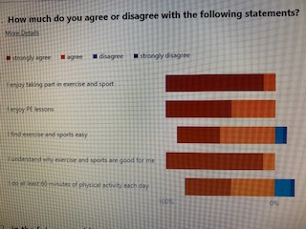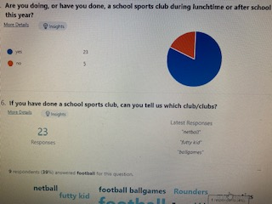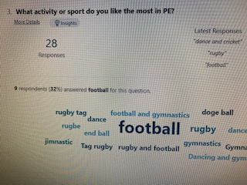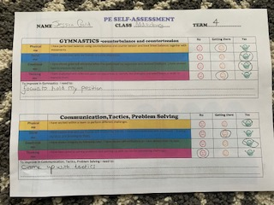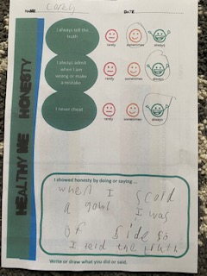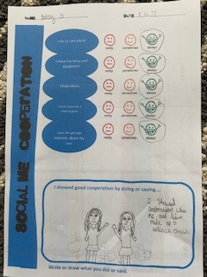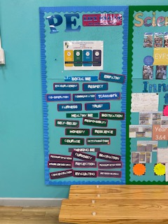  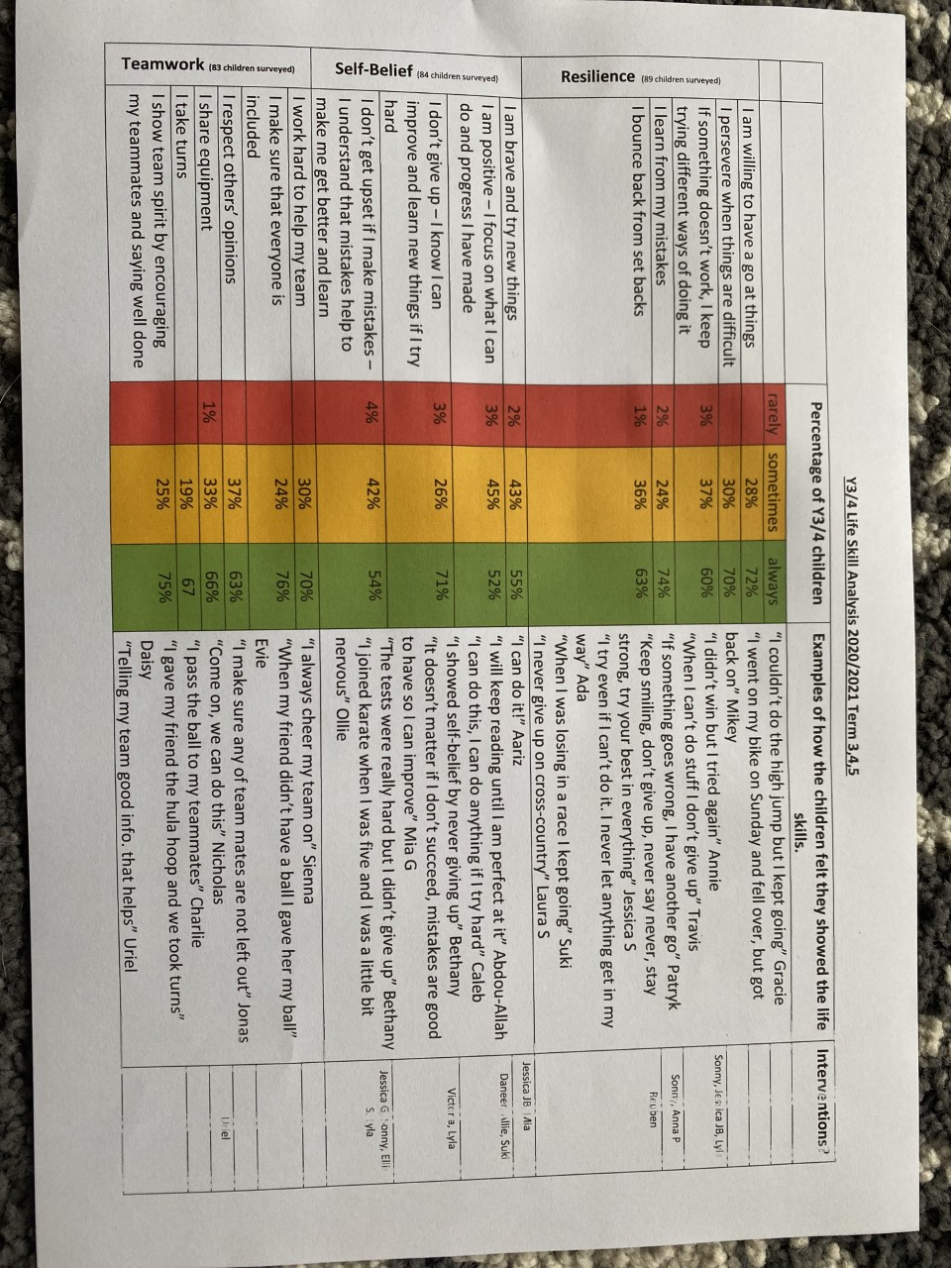
Section 4: Sustainability and Top Tips
Top Tips |  | Keep your vision simple and create a child facing version.  Make sure your resources and assessment aligns with your vision.  Invest in Complete PE or a similar resource.  Sign up to Will Swaithes Curriculum design course.

Permissions and Supporting Information
Approved quotes | Consent to use quotes included in the case study? Yes  Consent to use photos included in the case study? Yes
Consent to share | Consent to share case study? Not sure  Consent to share case study given by:  - Name:  - Role:  - Organisation:
Date of case study | Include date that the case study was compiled.  14/04/22

