Q. What is the Youth Sport Trust Quality Mark?
It is an online self review tool which provides a school with a nationally recognised badge of excellence for PE and school sport.
The easy to use tool supports schools to:
- Reflect on all aspects of their PE, school sport and physical activity offer encouraging a thorough reflection of practice
- Highlight the strength of PE in the school
- Help identify and prioritise further developments

The tool comprises a series of questions in 5 sections (NEW - same for primary and secondary):
- Section 1: Overall – vision, leadership and management
- Section 2: High quality physical education
- Section 3: High quality school sport
- Section 4: High quality physical activity
- Section 5: Using PE, school sport and physical activity to drive whole school improvements

Q. Why should a school complete the YST Quality Mark?
Particularly at gold level it is a badge of honour. It demonstrates the value the school places on its provision and reflects the whole school approach and commitment to providing a high-quality physical education, school sport and physical activity offer for all pupils.

Q. Is the YST Quality Mark the same as the School Games Mark or the AfPE Quality Mark?
No, they are separate things. The YST Quality Mark is a developmental tool that allows schools to thoroughly review their provision across the areas identified above. It can be completed up to three times a year providing opportunity for schools to continually develop and review their provision and receive recognition for this as the year progresses. The action planning guidance tailored to the school’s response to each question supports schools to do this.

The School Games Mark can only be achieved if the school is registered to take part in the Schools Games (www.yourschoolgames.com) and describes a school’s sport outcomes only, such as numbers of participates, leaders etc.

The AfPE Quality Mark identifies a school’s provision in relation to PE and school sport only. It does not look at whole school provision or provide ongoing developmental support.

Q. What value does the Quality Mark have with Ofsted?
The Quality Mark questions have strong links to the Ofsted framework but are not totally aligned; this is to allow for flexibility and changes to the Ofsted framework. Ofsted reports and discussions have shown that the inspectorate see the review against the Quality Mark in a very positive light.

Q. Which schools can access the Quality Mark?
Member schools at any of the following levels:
- Core
- Plus
- Premium

Q. If a school has previously completed a YST Quality Mark, will their responses be automatically entered into the platform?
No. If a school has an active QM though, in that it still has a year until it expires, we will still recognise this, but the school would need to register on the platform if they want to review their provision against the new Quality Mark questions and guidance.

Q. How does a school access the Quality Mark?
Once a school is registered on the CRM, within 24hrs they receive an automated email welcoming them to membership and directing them to the membership dashboard. When they click on the Quality Mark tile on their membership dashboard, they are taken to a hidden Quality Mark website page that includes these FAQ’s and the link to the Quality Mark platform.

Here’s the tile on the membership area:

The platform can be accessed directly at: https://ystqualitymark.org/. Schools are encouraged to bookmark this page to save them going through the membership dashboard each time they want to access the QM.

Q. How does a school log in to the Quality Mark platform?
From the Home page on the platform, click on ‘Sign up’ in the blue box in the top right corner.

You are then taken to a simple form where you enter you details, select your school, create a password and click on register at the bottom of the box. If you can’t’ find your school contact membership@youthsporttrust.org.

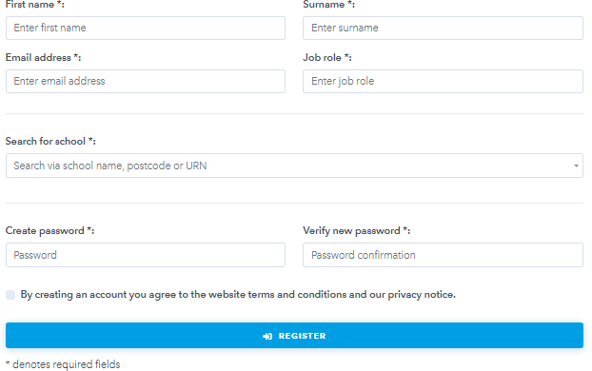

On completing the sign-up form and clicking ‘register’ a school is taken straight to their quality mark school page.

Q. Does a school need to sign in every time?
No, having signed up, next time the school visits the Quality Mark web site they ‘Login’ using the email address and password they created when signing up.

Q. What does a school see when they log in?
The school dashboard will look something like this, with different information appearing in each of the 3 boxes depending on whether the school has started or completed any previous Quality Marks.

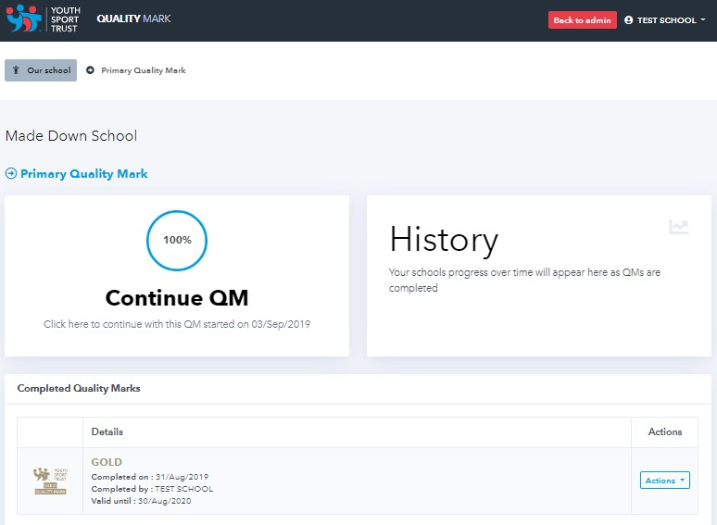

Q. How does a school complete the Quality Mark?
They click on ‘Start QM’ (see Continue QM in the first red circle above). From here they are taken through to Section 1 and the first question.
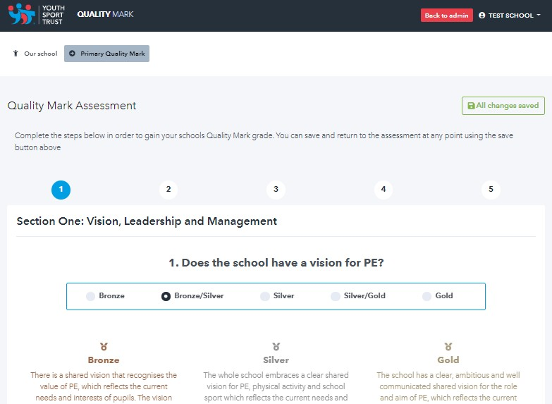

For each question, there is a bronze, silver and gold benchmarking statement. A school reviews the 3 statements in relation to their practice and then chooses one of 5 levels (NEW – bronze,

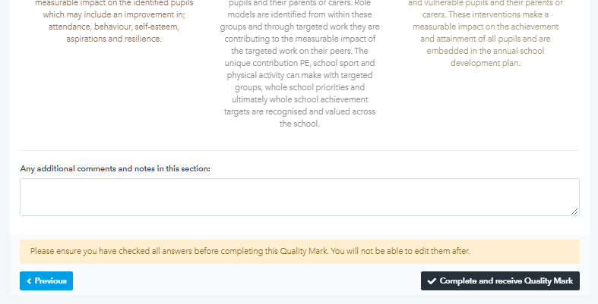
bronze/silver, silver, silver/gold, gold) that they determine is the appropriate level that they are at for that question.

Q. Why would a school choose bronze/silver or silver/gold?
These 2 levels provide schools with an opportunity to say we’re not quite at the next level, but we’ve embedded all the practise described in the level below and some of the practise but not all in the level above.

Q. Does it make a difference if a school chooses a bronze/silver or silver/gold?
Yes, the 5 responses carry a score of Bronze = 1 to Gold = 5. The final quality mark level is determined by the total score.

Q. Can a school save their answers and come back to them later?
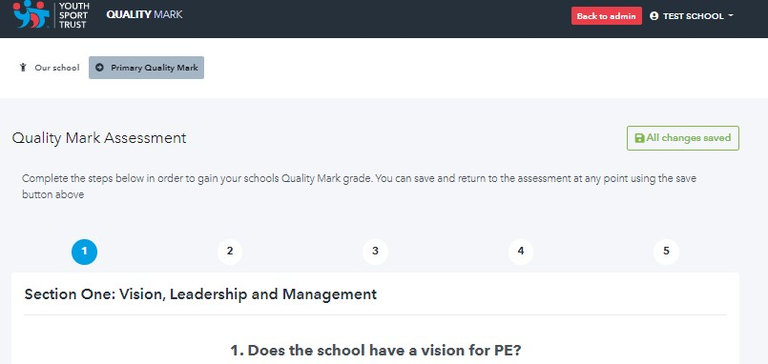
Yes, they can manually save their responses, or the platform auto saves when you go onto another section.

Q. Does a school have to answer the questions in order?
No, they can start with any question in any section.

Q. Can a school print the questions?
No, not at the moment.

Q. Does a school have to submit their Quality Mark, or does it automatically submit?
At the end of the last question in section 5 there is a black submit button. Schools don’t have to submit at this stage, they can save their answers and still go back in and alter them as many times as
they want before they submit.

Q. How many questions are there?
There are 24 questions in total. The number of questions at primary has increased slightly and at secondary has decreased slightly.

Section 1 | 5
Section 2 | 10
Section 3 | 2
Section 4 | 2
Section 5 | 5

Q. Have the questions changed from previous quality marks?
Primary – yes significantly. The previous primary quality mark was written just as the PE and sport premium funding was announced; therefore the questions and benchmarking statements (bronze in particular) were written as if there was limited or no practice established. 5 years on we would expect schools to have strengthened their practice considerably, therefore the questions reflect an established PE Lead who has had 5 years to make significant changes to practice. The emphasis has also changed with significantly more questions being asked at primary in the high-quality PE section than previously.

Secondary – slightly, see below.

At both primary and secondary, the benchmarking statements have also been written to reflect the new Ofsted inspection framework, emphasis on intent, implementation and impact as well as the new personal development section. The new YST PE curriculum blueprint is also referenced especially in relation to the intent of the curriculum and whether curriculum PE explicitly develops physical as well as personal skills.

Q. How long does it take to complete?
About 2 hours, if you don’t agonise over your responses. The advice is to read the silver benchmarking statement and then adjust to bronze or gold depending on the self review of your provision against the silver criteria. Ideally several people in a school would complete and you’d compare your answers which may take more time.

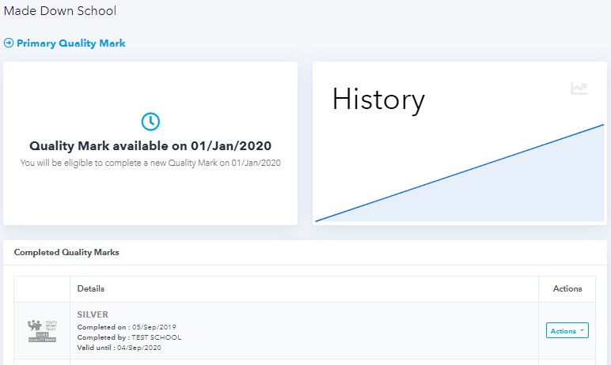
Q. What levels can a school achieve on completing the Quality Mark?
They can achieve one of three levels;
- Bronze
- Silver
- Going for Gold

Q. How long does a Quality Mark last for?
It lasts for 1 calendar year from the point of submission but can be reviewed and resubmitted from the start of each new academic term (NEW). Providing the opportunity for a school to embed identified developments and receive recognition for enhanced provision.

Q. Is the Quality Mark validated or quality assured?
At bronze and silver level there is no further validation of a schools Quality Mark responses. The Quality Mark is a development tool and it is anticipated that by a school self assessing their provision at bronze or silver level they will further develop their practice in an aim to achieve gold.

If a schools Quality Mark level is gold, on submission they will receive the following notification on the platform:

All YST Core, Plus and Premium member schools who are ‘going for gold’ are externally validated by a Youth Sport Trust team member. A validation visit is an opportunity for a school to showcase their gold provision and receive developmental support to help them extend their practice further.

Q. What does a school get for completing the Quality Mark?
Schools get access through the Quality Mark platform to a digital celebration pack containing:

- A downloadable personalised certificate
- A downloadable high-resolution logo to use on their school website, letterheads or print out and display
- In addition, Gold Quality Mark schools will receive a framed personalised gold quality mark certificate through the post to display proudly at their school.

Schools will also be able to select suggested developments or identify their own to create a personalised action plan to support further develop and embed their provision.

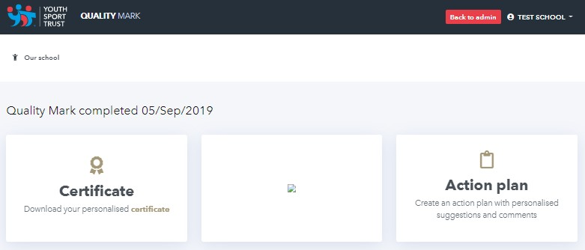
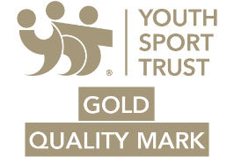
Q. Can a schools Quality Mark status be revoked?
We wouldn’t expect it to be, but a school should continue to be a YST member to use a YST Quality Mark logo.

