Fact File

This could be completed together with a young person or be provided for them to complete on their own. If you feel that this captures the right information for your audience then this could be a final output on its own.

 | Age:  School:  What I like doing…
 | I was looking forward to being involved in the programme because…
 | As part of this programme I have done…
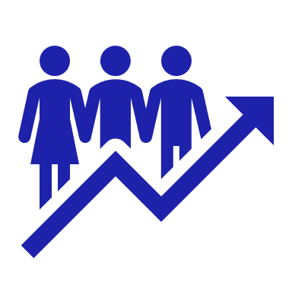 | Because of the programme I feel….
 | In the future the things I’ve learnt through this programme will help me to…

