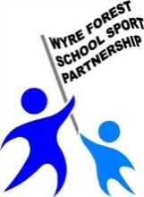
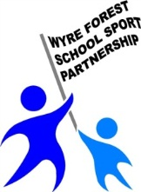
Wyre Forest School Sport Partnership
IMPACT
SCHOOL | School to complete
ACTIVITY
DATE
PUPILS: YR GROUP | NUMBERS | PP | SEN | G &T
 | School to complete

PE SCHOOL SPORT HEALTHY ACTIVE LIFESTYLE

Where does this activity/event meet the OfSTED descriptors?
- Increase in participation rates
- Increase and success in competitive school sports
- Inclusive PE curriculum
- Range of provisional and alternative sporting activities
- Partnership work on physical education with other schools and other local partners
- Links with other subjects that contribute to pupils’ overall achievement
- Increase awareness about the dangers of activities that undermine pupils’ health.
What were we trying to achieve?
What actions were taken?
What was the impact on participants?
What was the impact on my school?
School to complete

Next steps?
School to complete

