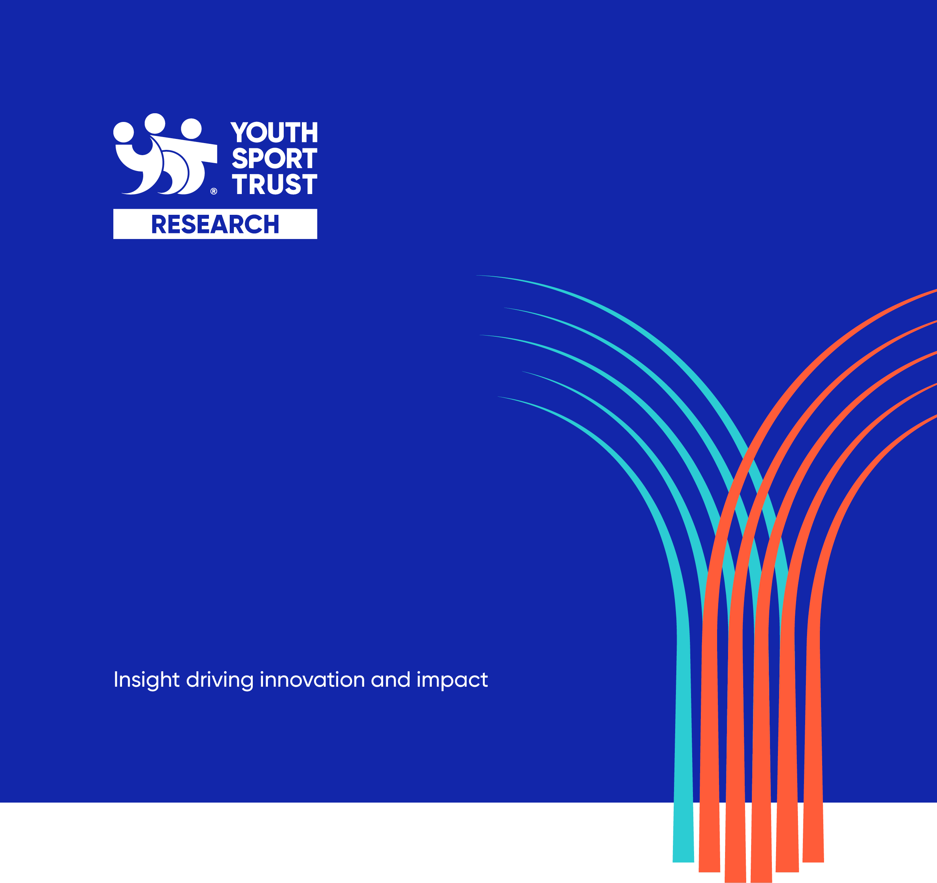

School Games Mark Validation Research Brief

September 2023

Contents
Introduction 1
About the Project 2
Delivery milestones 2
Aims and Objectives of Research 3
Methodology 4
Research Deliverables 4
Key Contacts 5
Research Timescales 5
Research Budget 6
The Bidding Process 7
Selection Process 7
Timetable 7
Selection Criteria 7
Proposal Requirements 7
Further Information 8
Proposal Submission 8

Introduction
The Youth Sport Trust (YST) is a national children's charity passionate about creating a future where every child enjoys the life-changing benefits that come from play and sport. We are on a mission to pioneer new ways of using sport to improve children’s wellbeing and give them a brighter future.
For more information about our organisation, please visit our website: www.youthsporttrust.org.
The YST is seeking to appoint an external research organisation to conduct a validation exercise of the School Games Mark.
This document sets out the research requirements for the research.

About the Project
The School Games Mark is a government led awards scheme launched in 2012 to reward schools for their commitment to the development of competition across their school and into the community. Participating in this process allows schools to evaluate their engagement in the School Games and their school sport provision and assists them in developing an action plan for future progress.
The School Games Mark is included in the Government’s 2023 updated School Sport and Activity Action Plan. Page 21 outlines how the new equality criteria will be phased into the scheme this year.
School Games registered schools are eligible to apply once a year during an application window, which traditionally takes place during the summer term, and are graded against set criteria. The School Games Mark is a retrospective award and all answers submitted should only consider the current academic year (i.e. the current term and the two previous terms). Applications are made via a short form available to all registered schools through their online dashboards.
When an application is submitted to us, it is graded automatically against that year's criteria. This initially determines whether the application is likely to be at a bronze, silver, or gold level. The application is then verified by that school's local School Games Organiser (SGO). We wish to bring some consistency and rigour to the applications and so wish to incorporate some random applications to be selected for a validation visit by an external auditor. The intention is that the appointed auditors will randomly select a small cohort of schools each year to ensure that the information being provided is correct.
The schools who consistently submit gold level applications will be given the opportunity to additionally apply for the platinum award, which is then valid for two years. A full set of guidance documents on the School Games Mark are available to all registered users via the resource library on their dashboard.
The Youth Sport Trust are seeking for a partner to act as an external auditor to help validate the School Games Mark 2023/24 and 2024/25. Consideration should also be given as to how the external validation can incorporate the capturing of good practice, learning and the impact of schools.

Delivery milestones
milestone | date
Project plan to Sport England | December 2023
School Games Mark 23/24 opens | September 2023
School Games Mark 23/24 submission window | May – July 2024
Validation window 23/24 | May – October 2024
Reporting on year 1 | December 2024
End of Award Report due to Sport England | March 2025
School Games Mark 24/25 opens | September 2024
School Games Mark 24/25 submission window | May– July 2025
Validation window 24/25 | May – October 2025
Final report | December 2025

Aims and Objectives of Research
The research has three strands
- Validation of the School Games Mark for a sample of schools.
- Explore and demonstrate the impact of the School Games Mark on schools.
- Capture examples of good practice and learning, this will be themed in the first instance around equality opportunity.
Key areas of focus:
- Capture good practice and learning.
- Capture the impact of the School Games Mark on schools.
- Validate a sample of schools with a wide geographic and level mix (Bronze, Silver, Gold and Platinum)
- Share the findings with each school validated (1 page summary report per school validated)
- To liaise with our website digital agency to bring about improvements to the application process
- To interrogate the data nationally to look for trends and key headlines
- Share the findings with Sport England and key stakeholders

The key research questions are outlined in the following table:
research component | key research questions
Process Evaluation | - How effective were the new questions on equality of opportunity? How easy were they for schools to understand, interpret and evidence?  - What are the key motivations for schools to participate in the School Games Mark award?  - What are the key criteria for successful implementation of the School Games Mark?  - What factors need to be in place to ensure lasting impacts?
Outcome Evaluation | - What are the challenges for schools in delivering equality of opportunity?  - What impact does the School Games Mark have on the whole school, PE teams and young people?  - To what extent would the outcomes have been achieved without the School Games Mark?  - To what extent does the School Games Mark contribute to long term impact?

Methodology
The YST would like researchers to propose a methodology that best meets our needs. However, we have outlined a number of key methodological considerations:
- Face to face and virtual validation approaches of a sample of schools including their School Games Organiser

- A summary of findings from the School Games Mark data each year.

- A focus on the new criteria relating to equality of opportunity for girls’ provision included this year.

- Both quantitative and qualitative research methods.

- Case studies covering a range of perspectives and activities capturing good practice. These should be available as standalone documents but also integrated into the main report structure. We welcome suggestions as to how these can be gathered and showcased in creative ways.

- The YST will make relevant contact details available to the successful researcher, and any additional data / information that would help the evaluation project.

Research Deliverables
The following deliverables are required from this research project:
- Inception note: Following the inception meeting, a full research methodology, with associated timescales and research tools.
- Monthly progress updates: Regular updates on progress and any challenges/ risks in the project.
- Year 1 Interim report (August 2024): To focus on the activity to date plus any broader emerging findings from wider programme delivery.
- Year 1 Final report November 2024): The YST would like one final report that integrates all sources of evidence and provides us with an understanding of the outcomes achieved, and recommendations to inform future delivery (maximum of 20 pages). There will be one single report, but we would value individual sections that look in more detail at each of the component parts. The report should be accompanied by a two-page executive summary and a one page infographic that can be shared with the School Games Network.
- Year 2 Interim report / presentation (August 2025): To focus on the activity to date plus any broader emerging findings from wider programme delivery.
- Year 2 Final report (November 2025): The YST would like one final report that integrates all sources of evidence and provides us with an understanding of the outcomes achieved, and recommendations to inform future delivery (maximum of 20 pages). There will be one single report, but we would value individual sections that look in more detail at each of the component parts. The report should be accompanied by a two-page executive summary and a one page infographic that can be shared with the School Games Network.
- Case Studies: Stand alone examples of good practice and learning, highlighting the value and impact of the School Games Mark and ones capturing practice around equality of opportunity. These will be delivered in year 1 and year 2
- Liaison with YST and Digital Developers Your input is required to help inform the future developments of School Games Mark, this includes improvements to the on-line experience and the criterion.
- Data files: Any survey data files should be made available, in an appropriate format.

Further guidance on the report content, style and structure will be given to the successful organisation at the inception meeting.

Key Contacts
The research project would be overseen by Lucy Slavin and Sorcha Paget. Clare Warburton is the programme manager for the School Games Mark overall.

Research Timescales
The timescales for the research project are detailed in the following table.
milestone | Date
Inception Meeting | November 2023
Inception Note | December 2023
Monthly update reports / meetings | Monthly from January 2024 – December 2025
Year 1 Interim Report / Presentation | August 2024
Year 1 Case Studies | September 2024
Year 1 Final Report and Infographic | November 2024
Year 2 Interim Report / Presentation | August 2025
Year 2 Case Studies | September 2025
Year 2 Final Report and Infographic | November 2025

Research Budget
The total budget for the research project is £160,000 (inclusive of expenses and VAT, if applicable).
Successful contractors will be paid against the following terms:
- 5% on a signed contract (December 2023)
- 20% upon satisfactory completion of the year 1 interim report / presentation (August 2024)
- 25% upon satisfactory completion of the year 1 final report (December 2024)
- 25% upon satisfactory completion of the year 2 interim report / presentation (August 2025)
- 25% upon satisfactory completion of the year 2 final report (December 2025)

The Bidding Process

Selection Process
Organisations are required to submit written proposals. Following a review of these, shortlisted organisations will be invited to our Loughborough office for interview on the Monday 23rd October. From this the successful organisation will be selected.

Timetable
milestone | Date
Expression of intent deadline | Friday 29th September 2023
Deadline for proposals | Tuesday 17th October 2023
Interviews | Monday 23rd October 2023
Successful organisation notified | Friday 27th October 2023
Inception meeting | Thursday 9th November 2023
Contract signed / first invoice received | December 2023

Selection Criteria
Proposals will be judged on the following criteria:
- Methodology, including a good understanding of the research requirements.
- Experience, particularly in relation to evaluation, young people, and inclusion.
- Value for money.

Proposal Requirements
You are invited to submit a written proposal which clearly outlines how you would meet the requirements laid out in this brief. Your proposal should be a maximum of 10 A4 pages (minimum font 11). CV’s, along with any other relevant information can be provided in appendices.
As a minimum, the following elements should be included in your proposal:
- Details of the proposed methodology.
- A brief overview of your organisation’s experience, including examples of similar research projects you have delivered.
- Details of the team who will be working on the research, including their role, previous experience and DBS status if applicable.
- Arrangements for managing the research and quality assuring the deliverables.
- Timetable for delivering the research.
- A breakdown of costs for undertaking the research, including a breakdown of time and costs per activity and per team member.

Further Information
Any questions you have which will help support the development of your proposals and relate to the project being evaluated should be emailed to lucy.slavin@youthsporttrust.org by Friday 29th September.
Please submit your expression of intent to submit a proposal by Friday 29th September.
Responses to queries will be emailed to all interested organisations.

Proposal Submission
Your final proposal should be emailed to lucy.slavin@youthsporttrust.org and received no later than close of play on the Tuesday 17th October.

YST RESEARCH

The Youth Sport Trust (YST) is a national children's charity passionate about creating a future where every child enjoys the life-changing benefits that come from play and sport. YST Research offers research, analysis, insight and evaluation services to organisations with an interest in the wider children and young people’s sector. Our research expertise is focussed on improving the wellbeing of children and young people through sport and physical activity.

Our specialisms include:
- Education, PE and school sport
- Community sport / clubs
- Early years settings
- Life skills and employability
- Activism and volunteering
- Health (physical, social and emotional)

For our latest research findings, visit
https://www.youthsporttrust.org/news-insight/research

By working with us, you are supporting us to achieve our mission to improve children’s lives and their future.



Youth Sport Trust
SportPark
Loughborough University
3 Oakwood Drive
Loughborough
Leicestershire
LE11 3QF

01509 226600
research@youthsporttrust.org
www.youthsporttrust.org



Registered Charity Number 1086915
Registered Company Number 4180163

The outcome evaluation should focus on assessing whether the short term outcomes were achieved, but the YST would welcome consideration for whether participants are on the right path to achieving the longer term outcomes.

