Dear Colleague
Schools Active Movement
We are very proud to announce that a new network has been established. The Schools Active Movement will specifically support the ‘extended network’ across England.
Schools Active Movement will:
- Connect - Provide effective communication for the extended network to build the movement and develop relationships
- Advocate - Support members to advocate their work locally and unify to create a collective voice to raise the profile nationally
- Share - Share good practice to allow the extended network to become even more effective in their work
The board consists of representatives volunteering from organisations across the country and has at least one member from each of the regions of England. We also have representation from YST which this movement will be ‘connected’ too.
Membership is free of charge and open to not-for-profit organisations with schools as part of the governance structure. We anticipate that many members will have a connection to the SGO role, if this is applicable to you, we ask that you are involved on a voluntary basis only and this does not form part of your SGO role.
How you join? Simple-please complete this snap survey https://wh.snapsurveys.com/s.asp?k=159982006209 as soon as possible. We will then be able to start communicating with you direct.
We hope that you will consider joining the ‘Schools Active Movement’. Our effectiveness will be dependent on being able to represent and connect with as many people and organisations as possible. Help us achieve our vision of supporting the extended network to ensure children are Happier, Healthier and More Active.
Yours faithfully
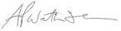
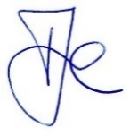
Vincent Brittain and Alan Watkinson on behalf of the Schools Active Movement Board

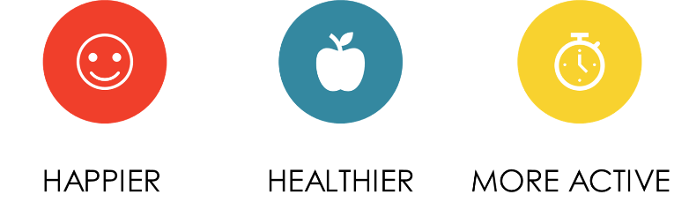
Schools Active Movement

